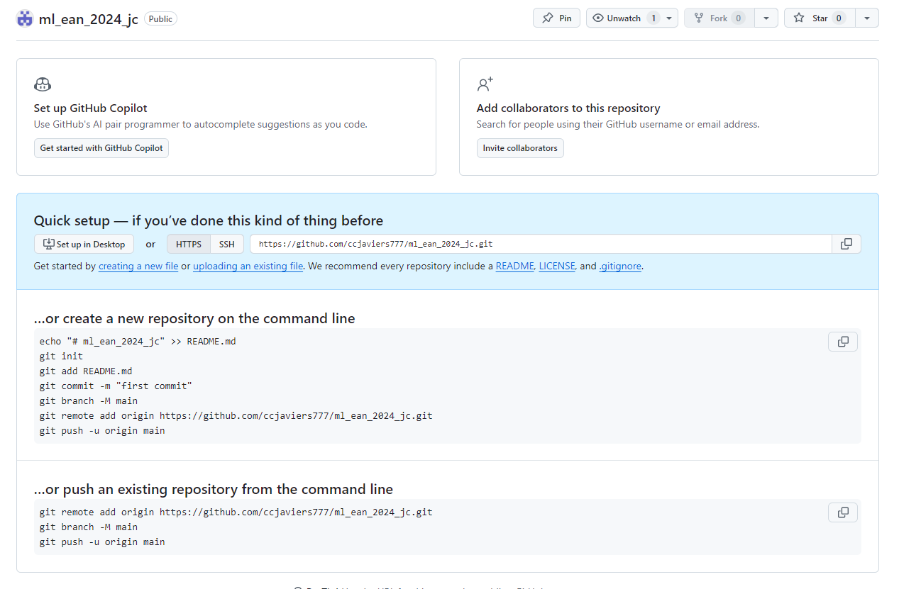

**…or create a new repository on the command line**

echo "# ml_ean_2024_jc" >> README.md

git init

git add README.md

git commit -m "first commit"

git branch -M main

git remote add origin https://github.com/ccjaviers777/ml_ean_2024_jc.git

git push -u origin main

**…or push an existing repository from the command line**

git remote add origin https://github.com/ccjaviers777/ml_ean_2024_jc.git

git branch -M main

git push -u origin main